Ideation Phase

Define the Problem Statements

|  |  |
| --- | --- |
| Date | 19 September 2022 |
| Team ID | PNT2022TMID16610 |
| Project Name | Smart Fashion Recommender Application |
| Maximum Marks | 2 Marks |

# Customer Problem Statement Template:

Create a problem statement to understand your customer's point of view. The Customer Problem Statement template helps you focus on what matters to create experiences people will love.

A well-articulated customer problem statement allows you and your team to find the ideal solution for the challenges your customers face. Throughout the process, you’ll also be able to empathize with your customers, which helps you better understand how they perceive your product or service.

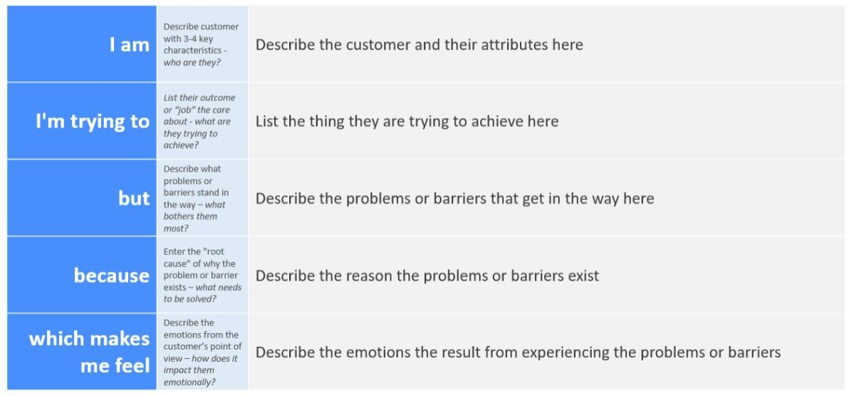

# Problem Statements

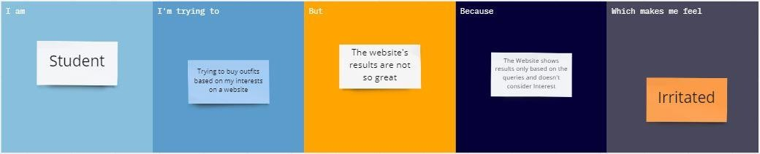

**Reference**: [https://miro.com/app/board/uXjVPR-2m2c=/?share_link_id=603347988234](https://miro.com/app/board/uXjVPR-2m2c%3D/?share_link_id=603347988234)

|  |  |  |  |  |  |
| --- | --- | --- | --- | --- | --- |
| **Problem**  **Statement (PS)** | **I am**  **(Customer)** | **I’m trying to** | **But** | **Because** | **Which makes me feel** |
| PS-1 | Social Media Influencer | purchase a latest fashion outfit | It doesn't suggests current trends and only show few latest  outfits | she doesn’t want to navigate around old fashioned products | Disappointed |
| PS-2 | Busy Manager | To purchase a formal outfit for an important meeting with my higher officials | It takes more time to search for the right product | He doesn’t want to waste time on searching casuals or any other themed  outfits | Frustrated |